**Sparse Matrix Array Implementation:**

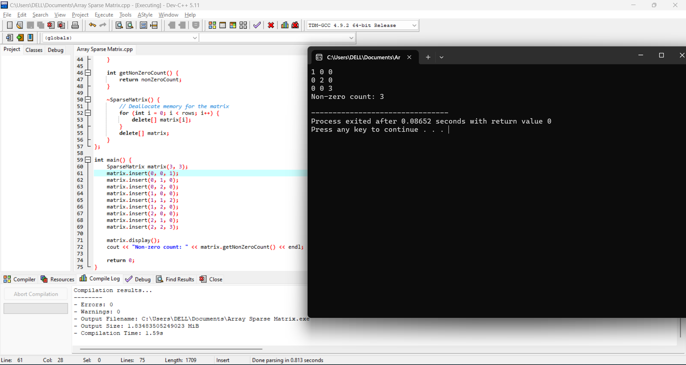

**Sparse Matrix Linkedlist Implementation:**

